**CHAPTER 1**

**INTRODUCTION**

The Lopifit (treadmill bicycle) is completely a new way of movement completely designed for runners. Typically using a treadmill basically is similar to running, hiking or walking.

Think about the last time you were riding a bike over some kind of obstacles such as train tracks, potholes, speed bumps. Possibilities are you stood up on the pedals to improve your balance when crossing the obstacle. Basically, the Lopifit will provide the rider a well-balanced position the entire time. It is a combination of amalgamation of DC motor with different components upgrading your walking speed to a much higher pace.

Since it uses no fuel it a very conventional option for people in their busy schedule to take care of their health completely. People with a busy schedule will also be able to take care of their health and physical fitness. Above all, it is not a conventional treadmill to make use of only in closed rooms, person using Lopifit can roam on roads also.

This project overcomes the drawback of the conventional treadmill which is stationary which in fact does not provide the jogger to get exposed to the natural atmosphere. So this proposed methodology provides an ultimate solution by making use of wheels and making the Lopifit a walking cycle.

**CHAPTER 2**

**PROJECT IN BRIEF**

**AIM:**

The main aim of this project is to help the people to commute in a cost effective mode of transportation without the use of renewable energy sources and eco-friendly to nature.

**OBJECTIVES:**

The Lopifit (treadmill bicycle) is a totally new way of moving with the electric assist it takes less effort to walk then “a walk in the park”. Nowadays, Increase in use of fuel has resulted in increase of pollution and degradation of natural resources. With increasing population and their need, it has become necessary to control the use of fuel and decrease the pollution, so as to make it avail it’s important to our coming generation. Due to heavy busy schedule people are not able to give attention to their health and physical fitness. As it uses no fuel so it saves energy simultaneously it can be used as treadmill and Bicycle. No need to use it as conventional treadmill in closed room you can roam on roads also.

**PROJECT TARGET:**

To implement the project to help the people to commute in a cost-effective mode of transportation without the use of renewable energy sources.

**CHAPTER-3**

**MODULAR DIAGRAM**

**MODULE 1 (12V/2A)**

LEAD ACID BATTERY

INPUT12V DC

OUTPUT12V DC

S**CHAPTER-4**

INDICATING LED ARRAY (EB087)

0)

12V

2A

MOTOR ROTATION

STEP UP TRANSFORMER (12-0-12)

12V REGULATOR (7812)

**MODULE 6**

**(4.5V/3.5A)**

**MODULE 5**

**(4V/2.5mA)**

**MODULE 8**

**(4V/1.5A)**

# DYNAMO GENERATOR DC MOTOR 4

# DYNAMO GENERATOR DC MOTOR 3

# DYNAMO GENERATOR DC MOTOR 2

# DYNAMO GENERATOR DC MOTOR 1

**MODULE 2(12V/2A)**

MOTOR

DRIVER 2 (L293D)

L298A

MOTOR

DRIVER 1 (L293D)

L298A

**MODULE 4**

**(5V/2A)**

**MODULE 3**

**(4V/2.5mA)**

A

T

M

E

G

A

3

2

8

P

**MODULE 7**

**(4.5V/3.5A)**

GPS MODULE

(GF-07)

GSM MODULE

(SIM900)

LCD DISPLAY

(16X2)

**MODULAR DIAGRAM DESCRIPTION**

**BLOCK DIAGRAM DESCRIPTION**

**MODULE 1: BATTERY**

* In Lopifit, Atmega microcontroller is used to control the input and output of the module.
* In Lopifit. Atmega328P series is used.

Microcontroller is work as main module to control in the Lopifit.

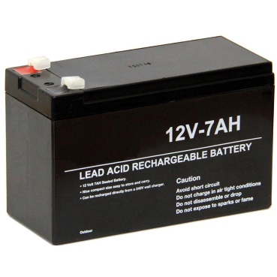

**MODULE 2: CHARGING CIRCUIT**

* Battery will charge from the motor rotation of the dynamo motor
* A battery charger generally supplies a regulated current first to charge the battery and then switches to a regulated voltage mode.
* **Input:12V,2A**
* **Output:12V,2A**

**MODULE 3: ATMEGA328P**

The ATmega328P is a low-power CMOS 8-bit microcontroller based on the AVR enhanced RISC architecture. By executing powerful instructions in a single clock cycle, the ATmega48P/88P/168P/328P achieves throughputs approaching 1 MIPS per MHz allowing the system designed to optimize power consumption versus processing speed.

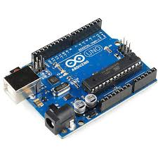

**MODULE 4: MOTOR & DRIVERS**

100RPM 12V DC geared motors for robotics applications. Very easy to use and available in standard size. Nut and threads on shaft to easily connect and internal threaded shaft for easily connecting it to wheel.

Motor drivers are made from discrete components which are integrated inside an IC. The input to the motor driver IC or motor driver circuit is a low current signal. The function of the circuit is to convert the low current signal to a high current signal. This high current signal is then given to the motor

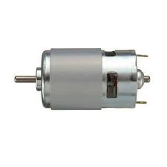

**MODULE 5: GPS MODULE**

The Global Positioning System (GPS), originally NAVSTAR GPS, is a satellite-based radio navigation system owned by the United States government and operated by the United States Space Force. It is one of the global navigation satellite systems (GNSS) that provides geo location and time information to a GPS receiver anywhere on or near the Earth where there is an unobstructed line of sight to four or more GPS satellites. Obstacles such as mountains and buildings block the relatively weak GPS signals

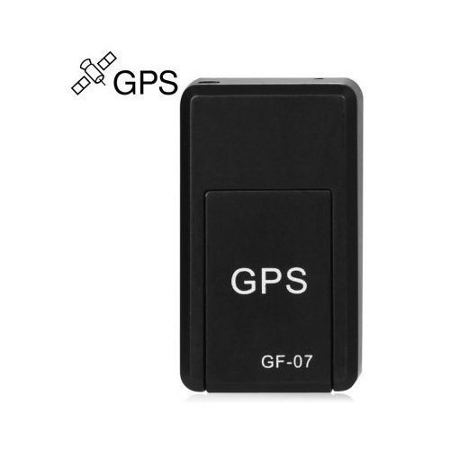

**MODULE 6: GSM MODULE**

A GSM module or a GPRS module is a chip or circuit that will be used to establish communication between a mobile device or a computing machine and a GSM or GPRS system. The modem (modulator-demodulator) is a critical part here. These modules consist of a GSM module or GPRS modem powered by a power supply circuit and communication interfaces (like RS-232, USB 2.0, and others) for computer. A GSM modem can be a dedicated modem device with a serial, USB or Bluetooth connection, or it can be a mobile phone that provides GSM modem capabilities.

**MODULE 7: LCD DISPLAY**

LCD (Liquid Crystal Display) is a type of flat panel display which uses liquid crystals in its primary form of operation. LEDs have a large and varying set of use cases for consumers and businesses, as they can be commonly found in Smartphone’s, televisions, computer monitors and instrument panels.

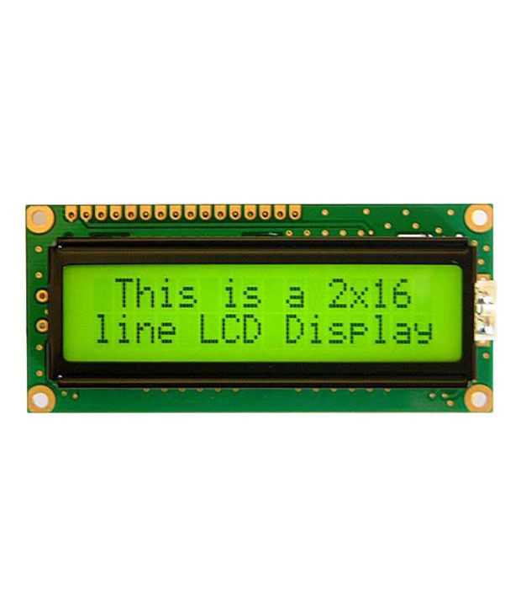

**MODULE 8: LED ARRAY**

An LED array or module refers to an assembly of LED packages (components), or dies (or chips) on a printed circuit board or substrate, oftentimes with optical elements whereby light generated by the at least an LED can have a desired pattern of distribution.

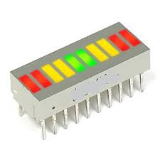

MODULE-1

**]BATTERY**

**(12V/2A DC)**

**CONTENTS**

➢

5.1 Description

➢

5.2 Block diagram

➢

5.3 Schematic diagram

➢

5.4 Design

➢

5.5 Bill of materials

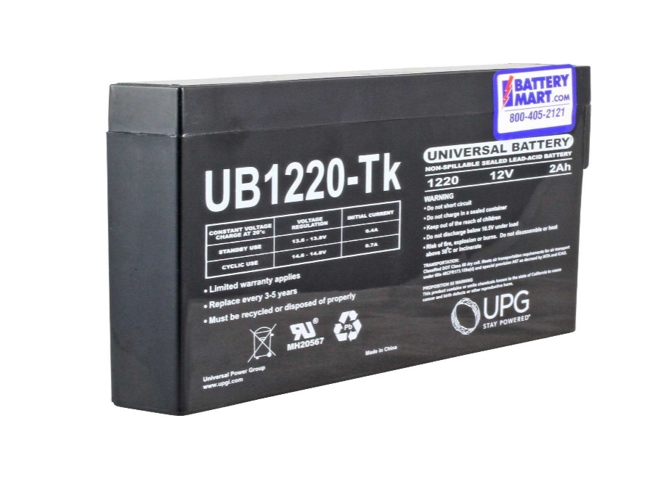

**CHAPTER 5**

**BATTERY**

**5.1 DESCRIPTION**

Battery is a collection of one more cell whose chemical reaction three basic components: an anode (the- side), a cathode (the + side) and some kind of electrolyte.

When the anode and cathode of a battery is connected to a circuit, a chemical reaction takes place between the anode and the Electrolyte.

This reaction causes electrons to flow through the circuit and back into cathode where another chemical reaction takes place.

When the material in the cathode or anode is consumed or no longer able to be used in the reaction, the battery is unable to produce electricity. At that point, your battery is “dead”

Batteries that must be thrown away after use are known as primary batteries. Batteries that can be recharged are called secondary batteries.

**5.2 BLOCK DIAGRAM**

OUTPUT12V DC

INPUT12V DC

LEAD ACID BATTERY

**BLOCK DIAGRAM DESCRIPTION**

A lead acid battery consists of a negative electrode made of spongy or porous lead. The lead is porous to facilitate the formation and dissolution of lead. The positive electrode consists of lead oxide. Both electrodes are immersed in a electrolytic solution of sulfuric acid and water.

**5.3 SCHEMATIC DIAGRAM**

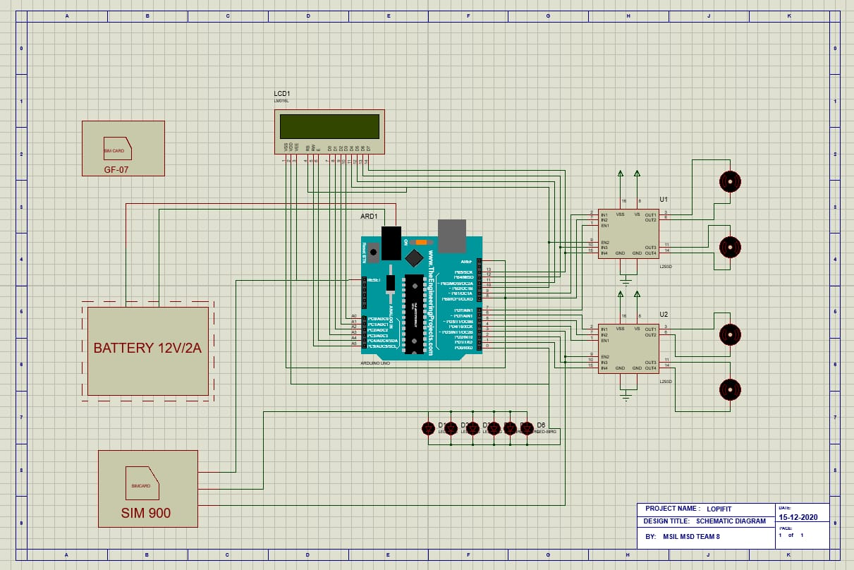

**5.4 DESIGN**

**Charging current calculation:**

**Charging current for 7Ah Battery = 7Ah x (10/100) = 0.7 Amperes.**

**Charging time calculation:**

Suppose we took 2 Amp for charging purpose,

then,

**Charging time for 7Ah battery = 7/2 = 3.5 Hrs.**

Practically, it has been noted that **40% of losses** occurs in case of battery charging.

Then 7 x (40 / 100) = 2.8 (7Ah x 40% of losses)

Therefore, 7+2.8 = 9.8 Ah (7Ah + Losses)

Now Charging Time of battery = Ah / Charging Current

Putting the values:

9.8 / 13 = 0.753 or 45.18 mins ( in real case)

Therefore, an 7Ah battery would take 45.18 mins to fully charge in case of the required 2A charging current.

**5.5 BILL OF MATERIALS**

|  |  |  |  |  |
| --- | --- | --- | --- | --- |
| **MODULE 1: POWER SUPPLY** | | | | |
| **S.NO** | **ITEM DESCRIPTION** | **SYMBOL** | **QUANTITY** | **PRICE** |
| 1 | 3 PIN POWER CORD  230V/ 10A (2.5m) | U | 1 | 60 |
| 2 | 5A - 3 WAY TERMINAL BLOCK  230V/ 5A | T1 | 1 | 30 |
| 3 | GLASS CARTRIDGE FUSE  5*20mm | F | 1 | 25 |
| 4 | FUSE BLOCK  5*20mm | F | 1 | 12 |
| 5 | CENTER TAP TRANSFORMER  15-0-15/ 2A | TR1 | 1 | 450 |
| 6 | POWER DIODE  1N5400(-50 TO 150 °C) | D1,D2,D3,D4 | 4 | 12 each |
| 7 | ELECTROLYTIC CAPACITOR  220nF/50V(-30 TO 70 °C) | C1 | 1 | 20 |
| 8 | BUCK CONVERTER  30V/2A | BC | 1 | 150 |
| 9 | LEAD ACID BATTERY  12V/7Ah | BATTERY | 1 | 750 |
| 10 | BATTERY CLIPS  MINI TYPE | BATTERY CLIPS | 2 | 15 each |

MODULE 02

MODULE 02

**CHARGING CIRCUIT**

**(12V/2A)**

* 6.1 DESCRIPTION
* 6.2 BLOCK DIAGRAM
* 6.3 BILL OF MATERIALS

**CHAPTER 6**

**BATTERY (12V,2A)**

**6.1 DESCRIPTION**

A battery charger, or recharger, is a device used to put energy into a secondary cell or rechargeable battery by forcing an electric current through it.

**BLOCK DIAGRAM**

12V

2A

MOTOR ROTATION

12V REGULATOR (7812)

STEP UP TRANSFORMER (12-0-12)

**BLOCK DIAGRAM DESCRTIPTION**

**INPUT**

* The input 12V/2A is given to the transformer.

**STEPUP TRANSFORMER**

* Most of the logic and digital circuit will work only a voltage less than 12V. That is why we are using a step-down transformer in a charging circuit.

**12V REGULATOR (7812)**

* 7812 Voltage regulators is a type of self-contained fixed linear voltage regulator integrated circuit. The ic 7812 Voltage regulators do operate at their optimal capability, if the input voltage is at least 2.5 volt greater than the output voltage (i.e 14.5 V min.) and the current is 1 or 1.5 Amperes more.

**6.4 BILL OF MATERIALS**

|  |  |  |  |  |
| --- | --- | --- | --- | --- |
| **SL NO** | **ITEM DESCRIPTION** | **SPECIFICATION** | **SYMBOL** | **QUANTITY** |
| 1 | STEP UP TRANSFORMER | 12-0-12 | T1 | 1 |
| 2 | 12V REGULATOR | 7812 | R1 | 1 |

MODULE-3

**ATMEGA328P MICROCONTROLLER**

**(12V/2A)**

* 7.1 DESCRIPTION
* 7.2 SCHEMATIC DIAGRAM
* 7.3 BILL OF MATERIALS

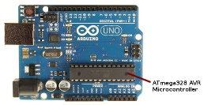

**CHAPTER 7**

**ATMEGA328P MICROCONTROLLER**

**7.1 DESCRIPITION**

ATmega-328 is basically an Advanced Virtual RISC (AVR) micro-controller. It supports the data up to eight (8) bits. ATmega-328 has 32KB internal built-in memory. This micro-controller has a lot of other characteristics. AT mega 328 has 1KB Electrically Erasable Programmable Read Only Memory (EEPROM). This property shows if the electric supply supplied to the micro-controller is removed, even then it can store the data and can provide results after providing it with the electric supply.

**FEATURES:**

ATmega-328 has 2KB Static Random-Access Memory (SRAM). Other characteristics will be explained later. ATmega 328 have several different features which make it the most popular device in today’s market.

These features consist of advanced RISC architecture, good performance, low power consumption, real timer counter having separate oscillator, 6 PWM pins, programmable Serial USART, programming lock for software security, throughput up to 20 MIPS etc. ATmega-328 is mostly used in Arduino. The further details about ATmega 328 will be given later in this section.

**SPECIFICATION**

* **ATmega328p**is an 8-bit and 28 Pins AVR [Microcontroller](https://www.theengineeringprojects.com/2018/03/introduction-to-microcontrollers.html), manufactured by Microchip, follows RISC Architecture and has a flash type program memory of 32KB.
* It has an EEPROM memory of 1KB and its SRAM memory is of 2KB.
* It has 8 Pin for ADC operations, which all combines to form PortA

( PA0 – PA7 ).

* It also has 3 built-inTimers; two of them are 8 Bit timers while the third one is 16-Bit Timer.
* You must have heard of Arduino UNO, UNO is based on atmega328 Microcontroller. It’s UNO’s heart.
* It operates ranging from 3.3V to 5.5V but normally we use 5V as a standard.
* Its excellent features include the cost efficiency, low power dissipation, programming lock for security purposes, and real timer counter with separate oscillator.
* It’s normally used in [Embedded Systems](https://www.theengineeringprojects.com/2016/10/what-is-embedded-systems.html) applications. You should have a look at these [Real Life Examples of Embedded Systems](https://www.theengineeringprojects.com/2016/11/examples-of-embedded-systems.html), we can design all of them using this Microcontroller.

**7.2 SCHEMATIC DIAGRAM:**



**7.3 BILL OF MATERIALS:**

|  |  |  |  |  |
| --- | --- | --- | --- | --- |
| **SL NO** | **ITEM DESCRIPTION** | **SPECIFICATION** | **SYMBOL** | **QUANTITY** |
| 1 | ATMEGA 328P | 12V DC | ARD1 - | 1 |

MODULE-4

**MOTORDRIVER (L293D)& DYNAMO DC MOTOR**

**(5V/2A)**

* 8.1 DESCRIPTION
* 8.2 SCHEMATIC DIAGRAM
* 8.3 BILL OF MATERIALS

**CHAPTER 8**

**MOTORDRIVER (L293D) & 100RPM DC MOTOR**

**8.1.1DESCRIPTION**

L293D is a typical Motor driver or Motor Driver IC which allows DC motor to drive on either direction. L293D is a 16-pin IC which can control a set of two DC motors simultaneously in any direction. It means that you can control two [DC motor](https://www.rakeshmondal.info/High-Torque-Motor-Low-RPM-Motor) with a single L293D IC. Dual H-bridge Motor Driver integrated circuit (IC).The l293d can drive small and quiet big motors as well, check the Voltage Specification at the end of this page for more info.

You can Buy L293D IC in any electronic shop very easily and it costs around 70 Rupees (INR) or around 1 $ Dollar (approx Cost) or even lesser cost. You can find the necessary pin diagram, working, a circuit diagram, Logic description.

**WORKING**

It works on the concept of H-bridge. H-bridge is a circuit which allows the voltage to be flown in either direction. As you know voltage need to change its direction for being able to rotate the motor in clockwise or anticlockwise direction, hence H-bridge IC are ideal for driving a DC motor.

In a single L293D chip there are two h-Bridge circuit inside the IC which can rotate two dc motor independently. Due its size it is very much used in robotic application for controlling DC motors. Given below is the pin diagram of a L293D motor controller.

There are two Enable pins on l293d. Pin 1 and pin 9, for being able to drive the motor, the pin 1 and 9 need to be high. For driving the motor with left H-bridge you need to enable pin 1 to high. And for right H-Bridge you need to make the pin 9 to high. If anyone of the either pin1 or pin9 goes low then the motor in the corresponding section will suspend working. It’s like a switch.

## L293D PIN DIAGRAM

[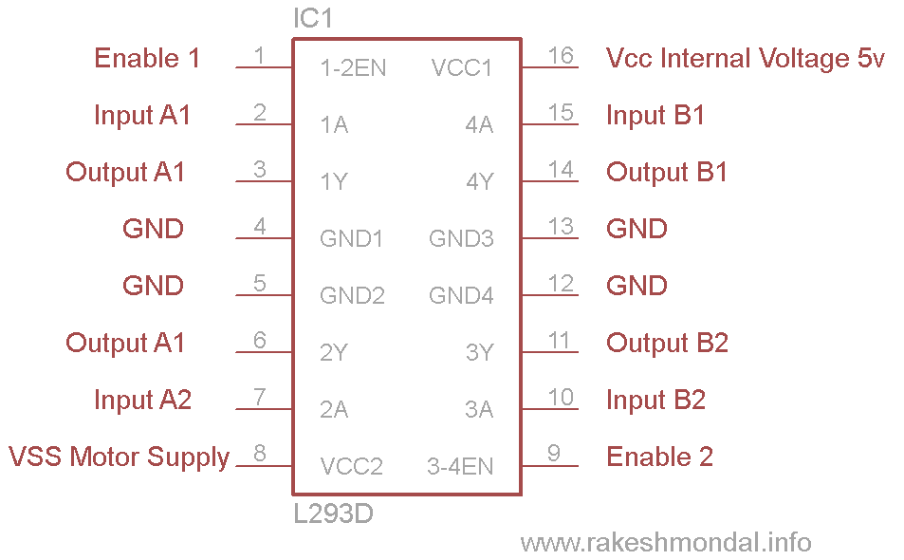](https://www.rakeshmondal.info/pik/l293d%20pin%20diagram.png)

## 8.2.1 SCHEMATIC DIAGRAM



**8.1.2 DYNAMO DC MOTOR**

**DESCRIPTION**

A dynamo is an [electrical generator](https://en.wikipedia.org/wiki/Electrical_generator) that creates [direct current](https://en.wikipedia.org/wiki/Direct_current) using a [commutator](https://en.wikipedia.org/wiki/Commutator_(electric)). Dynamos were the first electrical generators capable of delivering power for industry, and the foundation upon which many other later [electric-power conversion](https://en.wikipedia.org/wiki/Electric_power_conversion) devices were based, including the [electric motor](https://en.wikipedia.org/wiki/Electric_motor), the [alternating-current](https://en.wikipedia.org/wiki/Alternating_current) [alternator](https://en.wikipedia.org/wiki/Alternator), and the [rotary converter](https://en.wikipedia.org/wiki/Rotary_converter).

Today, the simpler alternator dominates large scale [power generation](https://en.wikipedia.org/wiki/Electricity_generation), for efficiency, reliability and cost reasons. A dynamo has the disadvantages of a mechanical commutator. Also, converting alternating to direct current using [rectifiers](https://en.wikipedia.org/wiki/Rectifier) (such as [vacuum tubes](https://en.wikipedia.org/wiki/Vacuum_tube) or more recently via [solid state](https://en.wikipedia.org/wiki/Solid_state_(electronics)) technology) is effective and usually economical.

**SPECIFICATIONS:**

* DC supply: 4 to 12V
* RPM: 100-500
* Total length: 57mm
* Motor diameter: 35mm
* Motor length: 57mm
* Brush type: Precious metal
* Output shaft: Centered
* Shaft diameter: 6mm
* Shaft length: 16mm
* Motor weight: 480gms

**8.2.2 SCHEMATIC DIAGRAM**



**8.3 BILL OF MATERIALS**

|  |  |  |  |  |
| --- | --- | --- | --- | --- |
| **SL NO** | **ITEM DESCRIPTION** | **`SPECIFICATIONS** | **SYMBOL** | **QUANTITY** |
| 1 | MOTOR DRIVER | L293D | U1,U2 | 2 |
| 2 | DC MOTOR | 100 RPM | M1,M2,M3,M4 | 4 |

MODULE-5

**GPS MODULE**

**(GF-07)**

* 10.1 DESCRIPTION
* 10.2 SCHEMATIC DIAGRAM
* 10.3 BILL OF MATERIALS

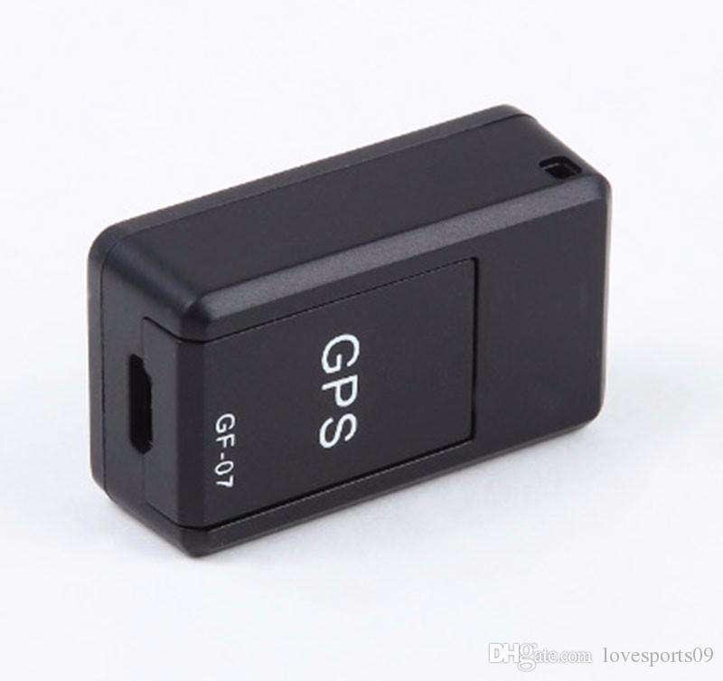

**CHAPTER-9**

**GPS MODULE (GF-07)**

**9.1 DESCRIPTION**

These are found in most smart phones, many new automobiles, and they are used to track commerce all over the globe. These tiny devices can instantaneously give your exact position and time, almost anywhere on the planet, for free! All you need is a [GPS receiver](https://www.sparkfun.com/categories/4), and receivers are getting less expensive and smaller every day.

There are decades of engineering that went in to giving you accurate position anytime, anywhere. Dozens of GPS satellites, all containing extremely accurate atomic clocks, have been launched since the late 70's, and launches continue to this day. The satellites continuously send data down to earth over dedicated RF frequencies. Our pocket-sized GPS receivers have tiny processors and antennas that directly receive the data sent by the satellites and compute your position and time on the fly. Simply amazing.

**SPECIFICATIONS**

Type: Magnetic GPS Locator  
Material: Plastic  
Size(approx):35*20*14mm  
Quantity: 1pc  
Color: Black  
Talk Time: 150 -180 minutes  
Standby Time: 12 days  
Working Time: 4 - 6 days  
Expansion Card: Mini TF card  
Network: GSM/GPRS  
GSM Band: 850/900/1800/1900Mhz  
GMS Locating Time: 25 Seconds  
Power Input: AC 110-220V 50/60Hz  
Power Output: DC5V 300 - 500mA  
Battery Capacity: 3.7V 400mAh Li-ion Battery  
Working Voltage: 3.4 - 4.2V DC  
Storage Temp.: -40 to 85 Celsius  
Operation Temp.: -20 to 55 Celsius  
Humidity: 5%-95% non-condensing  
Warning: Must insert SIM card before charging.

**FEATURES:**

1. Small size and light weight, easy for carry.  
2. Black shell, easy to hide, perfect for tracking vehicles, teens, spouses, elderly persons or assets. With two powerful magnets inside, easy to attach to vehicle firmly, no extra installation need.  
3. All you need is a working SIM card (NOT included!) to insert into the device, then you can track and map (with Google Maps) in real-time over the Internet.  
4. Dial SIM card number, then you can hear voice around this tracker, with no light and no noise, you can monitoring and spy what's going on around the tracker silently and secretly.

**ADVANTAGES**

1.It is the only similar products of all mobile phones on the map to view the query to the location and computer platform position trajectory, also can be directly reply messages in Chinese position.

2. In the first base station positioning on the basis of the original joined Google maps positioning, greatly reduces the error range of the product.

3. Due to the joined Google positioning mode, the product positioning function now support abroad.

4. If we can call 10086 opened around listening to sound more friendship number per month, it's only a number five year a month to check how long doesn’t have money.

5. This product does not need to cost platform, life-long free of charge. Just send a message to the alarm locator, can respond to the following address information in Chinese and Google maps connection, simple operation, one pace reaches the designated position.

6. This product built-in powerful magnet adsorption function, need not you worry again put problem, as long as there is metal, you can directly put up, the magnet will automatically adsorption, more convenient installation you put the position

7. This product is the only market with the function of charge automatically boot, connect the power supply, when the alarm locator electricity used up and products after shutdown, call the product will be automatically switched on and continue to recharge, warning, charging must insert SIM card Regardless of alarm locator on the cart, children bag, the old man's pocket, valuables bag, can through the mobile phone to send SMS alarm locator, query alarm locator location, convenient you to monitor all the way, to master the location of the object in real time.

**9.2 SCHEMATIC DIAGRAM**



**9.3 BILL OF MATERIALS**

|  |  |  |  |  |
| --- | --- | --- | --- | --- |
| **SL NO** | **ITEM DESCRIPTION** | **`SPECIFICATION** | **SYMBOL** | **QUANTITY** |
| 1 | GPS MODULE | GF-07 | G1 | 1 |

MODULE-6

**GSM MODULE**

**(SIM900)**

* 9.1 DESCRIPTION
* 9.2 SCHEMATIC DIAGRAM
* 9.3 BILL OF MATERIALS

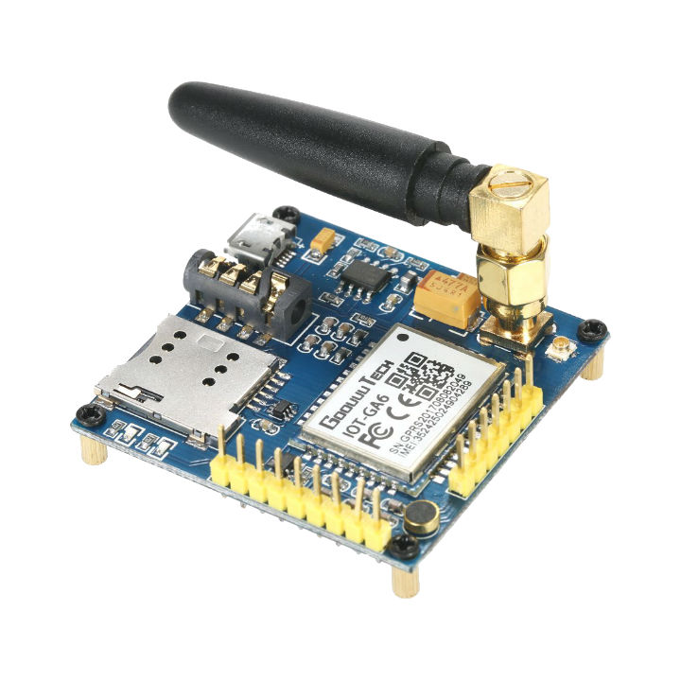

**CHAPTER 10**

**GSM MODULE**

**10.1 DESCRIPTION**

The SIM900 is a complete Quad-band GSM/GPRS solution in a SMT module which can be embedded in the customer applications. Featuring  an  industry-standard  interface,  the  SIM900  delivers GSM/GPRS 850/900/1800/1900MHz performance for voice, SMS, Data,  and  Fax  in  a  small   form  factor  and  with  low  power consumption. With a tiny configuration of 24mm x 24mm x 3 mm, SIM900 can fit almost all the space requirements in your M2M application, especially for slim and compact demand of design.

**FEATURES:**

* SIM900 is designed with a very powerful single-chip processor  integrating AMR926EJ-S core
* Quad - band GSM/GPRS module with a size of 24mmx24mmx3mm
* SMT type suit for customer application
* An embedded Powerful TCP/IP protocol stack
* Based upon mature and field-proven platform, backed up by our support service, from definition to design and production

**SPECIFICATION:**

* Quad-Band 850/ 900/ 1800/ 1900 MHz
* GPRS multi-slot class 10/8
* GPRS mobile station class B
* Compliant to GSM phase 2/2+
  + Class 4 (2 W @ 900 MHz)
  + Class 1 (1 W @ 1800MHz)
* Dimensions: 24x24x3mm
* Weight: 3.4g
* Control via AT commands (GSM 07.07 ,07.05 and SIMCOM enhanced AT Commands)
* SIM application toolkit
* Supply voltage range : 3.4V to 4.5V
* Low power consumption: 1.0mA(sleep mode)
* Operation temperature: -40°C to +85 °C

**ADVANTAGES:**

* GSM technology has been matured since long and hence GSM mobile phones and modems are widely available across the world.  
  It provides very cost effective products and solutions.
* The GSM based networks (i.e. base stations) are deployed across the world and hence same mobile phone works across the globe. This leverages cost benefits as well as provides seamless wireless connectivity. This will help users avail data and voice services without any disruption. Hence international roaming is not a concern.
* Advanced versions of GSM with higher number of antennas will provide high speed download and upload of data.  
  SAIC and DAIC techniques provide very high transmission quality. SAIC stands for Single Antenna Interference Cancellation technique while DAIC stands for Dual antenna interference cancellation.  
  It is easy to maintain GSM networks due to availability of large number of network engineers at affordable cost.
* The GSM signal does not have any deterioration inside the office and home premises. It is easy to integrate GSM with other wireless technology based devices such as CDMA, LTE etc.

**DISADVANTAGES:**

* Many of the GSM technologies are patented by Qualcomm and hence licenses need to be obtained from them.
* In order to increase the coverage repeaters are required to be installed.
* GSM provides limited data rate capability, for higher data rate GSM advanced version devices are used.
* GSM uses FTDMA access scheme. Here multiple users share same bandwidth and hence will lead to interference when more number of users are using the GSM service. In order to avoid this situation, robust frequency correction algorithms are used in mobile phones and base stations.
* GSM uses pulse based burst transmission technology and hence it interferes with certain electronics. Due to this fact airplanes, petrol bunks and hospitals prevent use of GSM based mobile or other gadgets.

**10.2 SCHEMATIC DIAGRAM**



**10.3 BILL OF MATERIALS**

|  |  |  |  |  |
| --- | --- | --- | --- | --- |
| **SL NO** | **ITEM DESCRIPTION** | **`SPECIFICATION** | **SYMBOL** | **QUANTITY** |
| 1 | GSM MODULE | SIM900 | GS1 | 1 |

MODULE-7

**LCD DISPLAY**

**(16X2)**

* 11.1 DESCRIPTION
* 11.2 SCHEMATIC DIAGRAM
* 11.3 BILL OF MATERIALS

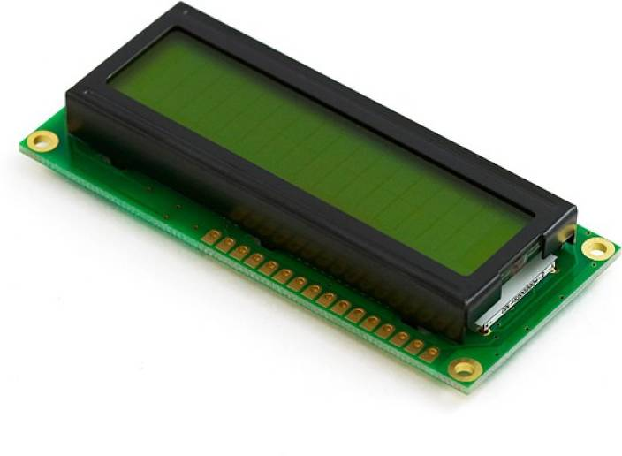

**CHAPTER-11**

**LCD DISPLAY (16X2)**

**11.1 DESCRIPTION**

LCD modules are very commonly used in most embedded projects, the reason being its cheap price, availability and programmer friendly. Most of us would have come across these displays in our day to day life, either at PCO’s or calculators. The appearance and the pinouts have already been visualized above now let us get a bit technical.

**16×2 LCD** is named so because; it has 16 Columns and 2 Rows. There are a lot of combinations available like, 8×1, 8×2, 10×2, 16×1, etc. but the most used one is the 16×2 LCD. So, it will have (16×2=32) 32 characters in total and each character will be made of 5×8 Pixel Dots.  A Single character with all its Pixels is shown in the below picture.

Now, we know that each character has (5×8=40) 40 Pixels and for 32 Characters we will have (32×40) 1280 Pixels. Further, the LCD should also be instructed about the Position of the Pixels. Hence it will be a hectic task to handle everything with the help of MCU, hence an **Interface IC likeHD44780**is used, which is mounted on the backside of the LCD Module itself. The function of this IC is to get the **Commands and Data** from the MCU and process them to display meaningful information onto our LCD Screen. You can learn how to interface an LCD using the above mentioned links. If you are an advanced programmer and would like to create your own library for interfacing your Microcontroller with this LCD module then you have to understand the HD44780 IC is working and commands which can be found its datasheet.

**FEATURES:**

* Operating Voltage is 4.7V to 5.3V
* Current consumption is 1mA without backlight
* Alphanumeric LCD display module, meaning can display alphabets and numbers
* Consists of two rows and each row can print 16 characters.
* Each character is build by a 5×8 pixel box
* Can work on both 8-bit and 4-bit mode
* It can also display any custom generated characters
* Available in Green and Blue Backlight

### ****2D MODEL OF 16×2 LCD MODULES:****

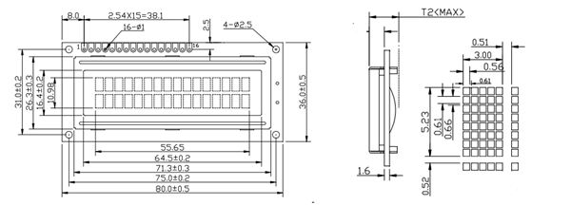

**11.2 SCHEMATIC DIAGRAM**



**11.3 BILL OF MATERIALS:**

|  |  |  |  |  |
| --- | --- | --- | --- | --- |
| **SL NO** | **ITEM DESCRIPTION** | **`SPECIFICATION** | **SYMBOL** | **QUANTITY** |
| 1 | LCD DISPLAY | 16X2 | LCD1 | 1 |

MODULE-8

**INDICATING LED ARRAY**

**(EB087)**

* 12.1 DESCRIPTION
* 12.2 SCHEMATIC DIAGRAM
* 12.3 BILL OF MATERIALS



**CHAPTER-12**

**INDICATING LED ARRAY (EB087)**

**12.1 DESCRIPTION**

The LED Array board allows the exploration of basic display control mechanisms. The board features an 8 by 5 LED matrix where each LED has its own buffer to maintain the state. Each LED buffer output is connected to the input of the next meaning that data cascades from one LED to the next starting from LED D0 and running through to LED D40. Multiple LED Array boards can be connected together to form a longer LED chain. Fitting the boards to a 20mm pitch E-blocks backplane allows a constant spaced message board type display to be created. The current for all of the LEDs is passed through a MOSFET which allows the LED’s brightness to be controlled or switched off when idle to save power. The display interface is capable of handling very high speed data allowing large display boards with high frame rate animations or scrolling text to be created.

**12.2 SCHEMATIC DIAGRAM**



AR1

**12.3 BILL OF MATERIAL**

|  |  |  |  |  |
| --- | --- | --- | --- | --- |
| **SL NO** | **ITEM DESCRIPTION** | **`SPECIFICATION** | **SYMBOL** | **QUANTITY** |
| 1 | LED | 5V DC | AR1 | 1 |

**CHAPTER-13**

**CIRCUIT DIAGRAM**



**CHAPTER-14**

**MECHANICAL DESIGN**

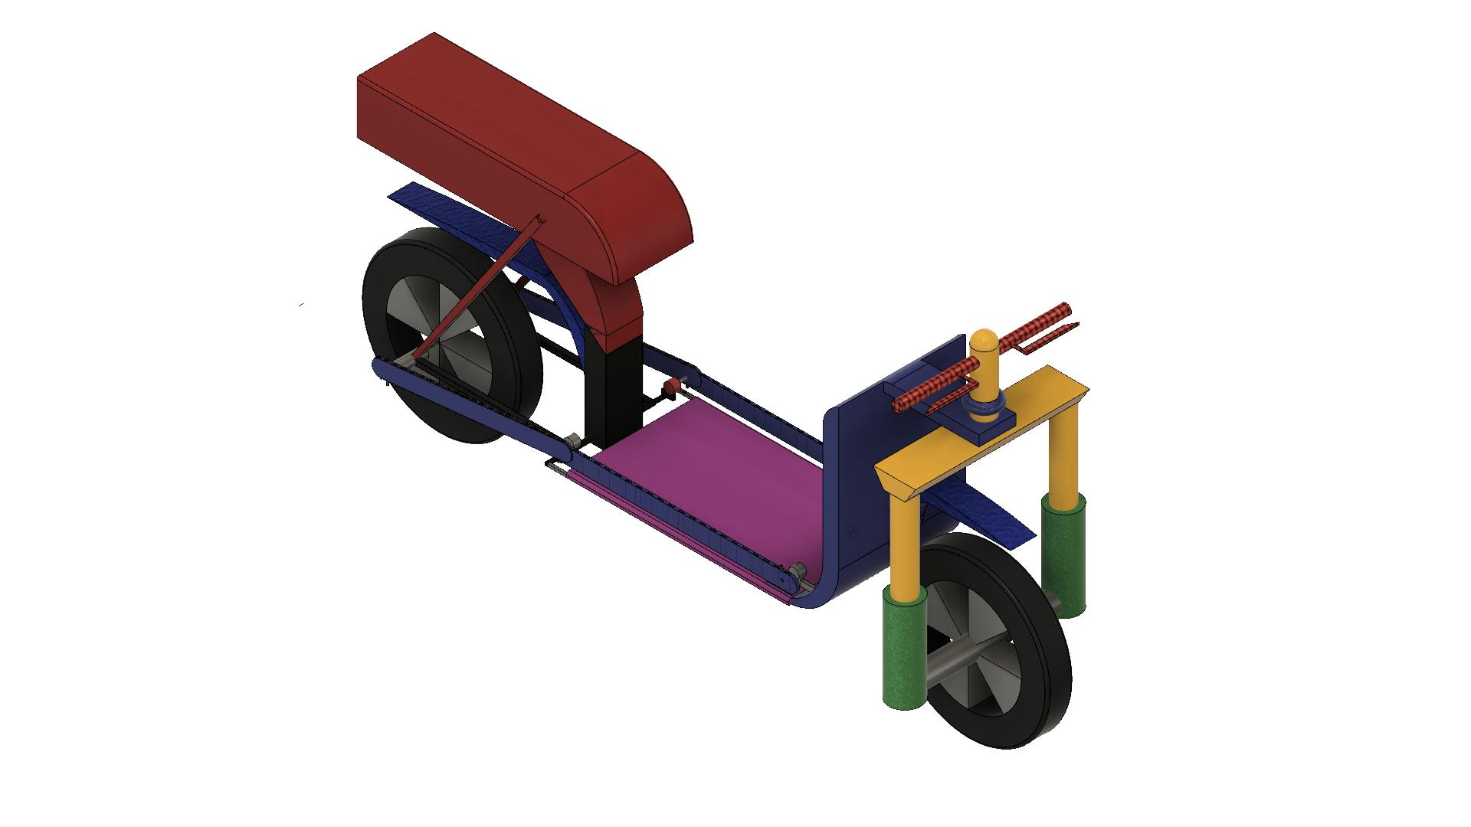**14.1 ISOMETRIC VIEW**

Frame

Head Tube

Suspension

Treadmill

Battery Box

Tires

**14.2 FRONT VIEW**

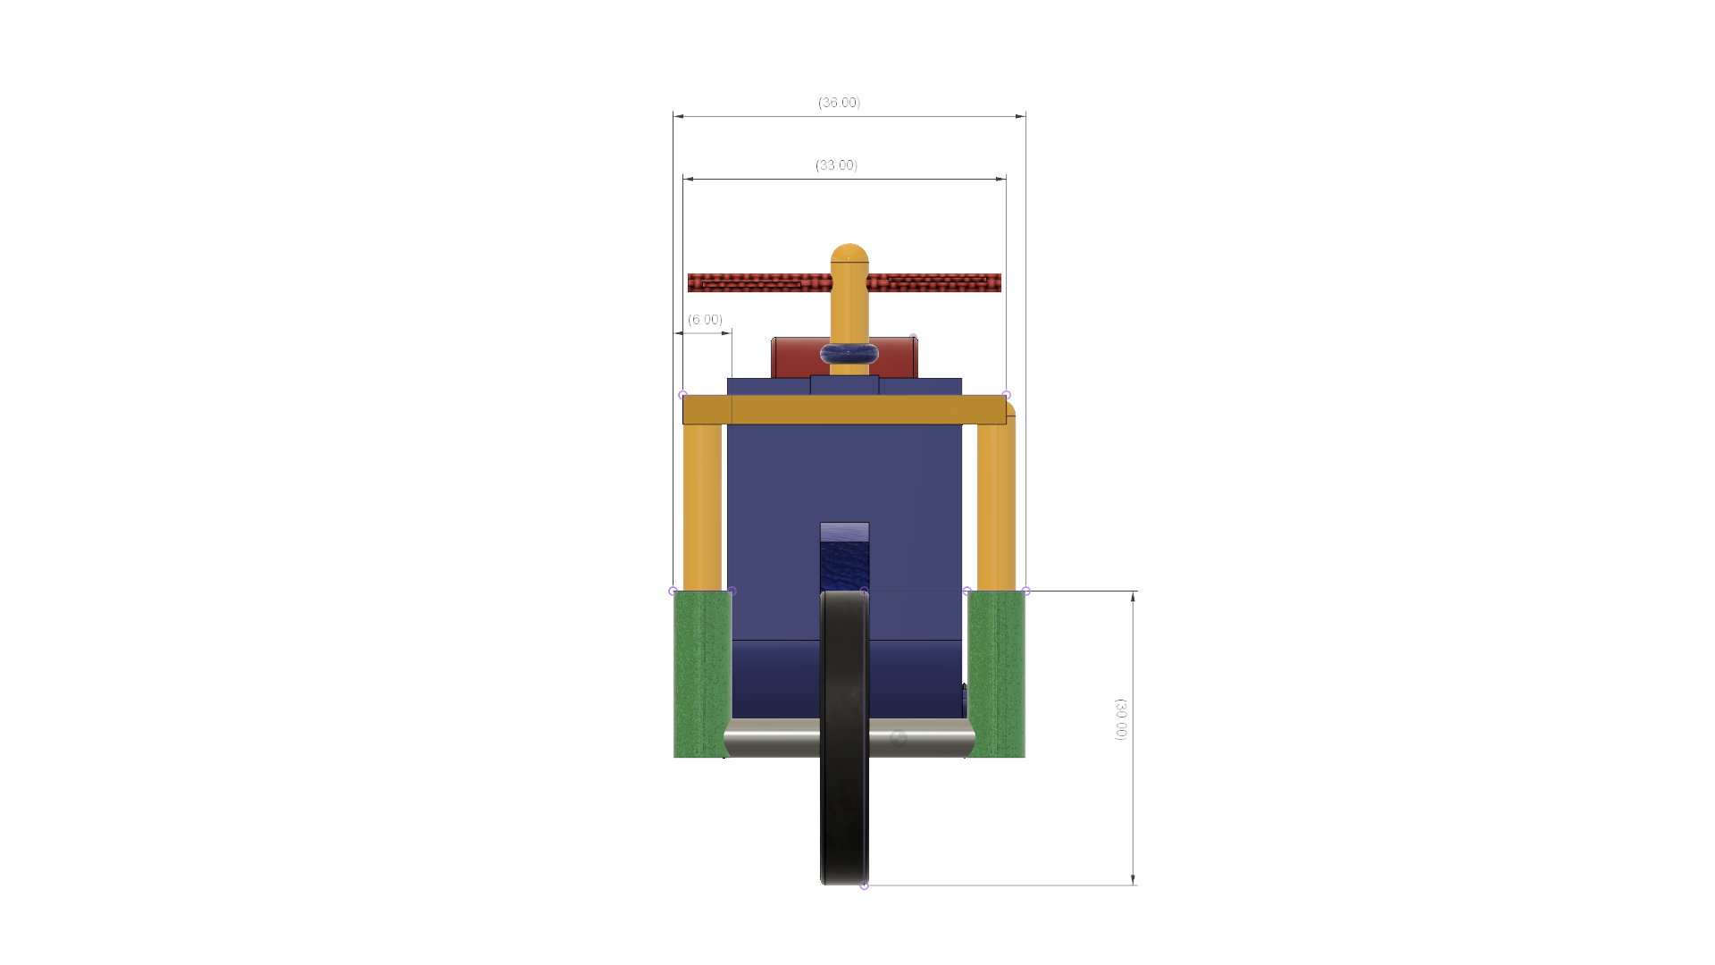

All dimensions are in mm

**14.3 SIDE VIEW**

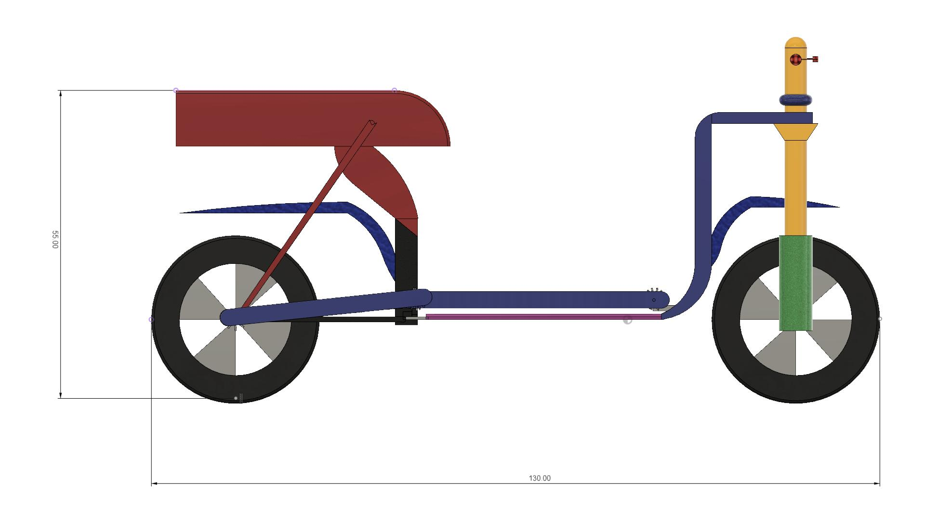

All dimensions are in mm

All dimensions are in mm

**CHAPTER-15**

**BILL OF MATERIALS**

**ELECTRICAL COMPONENTS**

|  |  |  |  |  |
| --- | --- | --- | --- | --- |
| **SL NO** | **MODULES** | **SPECIFICATION** | **QUANTITY (NO'S)** | **PRICE (INR)** |
| 1 | MODULE1: Battery | 7.5AH | 1 | **830** |
| 2 | MODULE2: Charging circuit (15v/1a) | CC | 1 | **635** |
| 3 | MODULE3: Arduino mega2560 (5v/1.5A) | ATMEGA328P | 1 | **450** |
| 4 | MODULES4: GPS MODULE(GF-07) | GF-07 | 1 | **900** |
| 5 | MODULE 5: Motor driver L298N & Motors(12v/1.5A) | L298N,100RPM | 2,4 | **250** |
| 6 | MODULE6: GSM MODULE(SIM900) | SIM900 | 1 | **900** |
| 7 | MODULE7: LED DISPLAY3(P10) | 32X16 | 1 | **500** |
| 8 | MODULE8: INDICATING LED ARRAY | 5V DC | 1 | **50** |
| 9 | Tool Kit | _ | 1 | **AVAILABLE** |
| **TOTAL** | | | | **4515/-** |

**MECHANICAL COMPONENTS**

|  |  |  |  |  |  |
| --- | --- | --- | --- | --- | --- |
| **SL NO** | **COMPONENTS** | **SPECIFICATIONS** | **MATERIAL** | **QUANTITY (NO'S)** | **PRICE (INR)** |
| 1 | Frame | 12X4 INCH | M.S | 1 | **900** |
| 2 | Wheels | 20” (BACK) 24”(FRONT) | Rubber | 2 | **1200** |
| 3 | Treadmill Belt | V BELT | Rubber | 1 | **900** |
| 4 | Roller | 12 INCH | M.S | 2 | **1000** |
| 7 | Sprocket | 15 INCH | Steel | 2 | **550** |
| 8 | Chain | 52 INCH | Steel | 1 | **560** |
| 10 | Bearing With Bearing Cap | 12 mm | M.S | 6 | **500** |
| 11 | Spur Gear | 10 to 200 mm | C.I | 2 | **650** |
|  |  |  |  | **TOTAL** | **6260/-** |

**GRAND TOTAL**

|  |  |
| --- | --- |
| **TYPE** | **PRICE (INR)** |
| ELECTRICAL | **4515/-** |
| MECHANICAL | **6260/-** |
| **TOTAL** | **10775/-** |

**CHAPTER-16**

**16.1 FUSION 360**

The mechanical design work was carried out using this software. The mechanical design could be drawn in 3 dimensions using this software.

**16.2 PROTEUS 8 PROFESSIONAL**

This software was used to draw the Schematic diagram, Circuit diagram and the interconnection diagram. It was also used to simulate and test certain programs.

**16.3 ARDUINO IDE**

The programming part of this project was done using this software. Debugging of the program was also done with this software.

ARDUINO IDE is free software which solves many of the pain points for the program developer. This software is an integrated development environment (IDE), which integrated a text editor to write programs, a compiler. Here is simple guide to start working with ARDUINOIDE which can be used for

* Writing programs in C/C++ or in python x
* Compiling and Assembling Programs
* Debugging program
* This is simple guide on 4 though also applicable on previous versions also. These are the simple steps to get off the mark your inning!

These are the steps you need to follow in order to be up and running:

1. Get an Arduino board
2. Download the Arduino environment
3. Install the USB drivers
4. Connect the board
5. Upload a program

### 1 | Get an Arduino Board

### The ArduinoI/O board is a simple circuit featuring the ATmega8 processor from Atmel. The board is composed of a printed circuit board (PCB) and electronic parts.

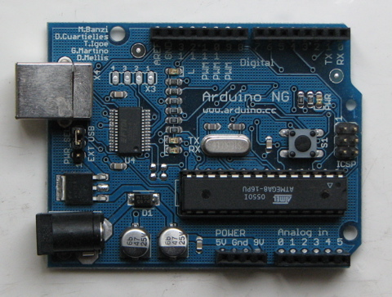

There are a few ways to get an Arduino board:

* **Buy a readymade board**: See how you can [buy](https://www.arduino.cc/en/Main/Buy) a board or just the PCB.
* [European distributor](http://pcb-europe.net/catalog/index.php?cPath=29) or [US distributor](http://www.sparkfun.com/commerce/product_info.php?products_id=666)
* **Build your own board**: If you want you can build your own PCB just by downloading the CAD files from the [Hardware](https://www.arduino.cc/en/Main/Hardware) page. Extract the .brd file and send it to a PCB manufacturer. Be aware that manufacturing a single PCB will be very expensive. It's better to get together with other people and make 20 or 30 at a time. Since you get the full CAD files you can make your own customized version of Arduino. If you make modifications or fix bugs please send us your changes!
  + **Purchase parts**: Purchase the parts from any electronics store. The Serial version in particular has been designed to use the most basic parts that can be found anywhere in the world. The USB version on the other hand requires some advanced soldering skills because of the FTDI chip that is asmd part. Here is a [list](https://www.arduino.cc/en/Main/PartsSerial) of parts for the serial board.
  + **Assemble the board**: We put together a step by step [guide](https://www.arduino.cc/en/Main/BuildSerial) on how to build an arduino board.
  + Newbie’s: never soldered before? Afraid of trashing thousands of boards before getting one properly soldered? Fear not :) learns to master the art of [soldering](http://www.potemkin.org/cms/Pid/Soldering).
  + **Program the boot loader**: In order for the development environment to be able to program the chip, this has to be programmed with a piece of code called boot loader. See the [boot loader](https://www.arduino.cc/en/Main/Bootloader) page on how to program it on your chip.

### 2 | Download the Arduino environment

* To program the Arduino board you need the Arduino environment.
* **Download Arduino**: From the [software page](https://www.arduino.cc/en/Main/Software).
* Linux note*: For help getting the Arduino IDE running on Debi an, please see the*[*FAQ*](https://www.arduino.cc/en/Main/FAQ)*("How can I run the Arduino IDE under Linux?").*

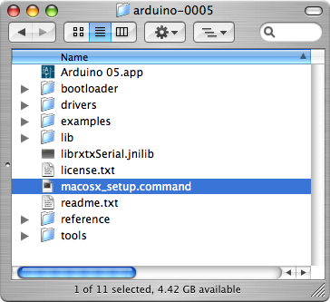

For more information, see the [guide to the Arduino environment](https://www.arduino.cc/en/Main/Environment).

### 3 | Install the USB drivers

If you are using a USB Arduino, you will need to install the drivers for the FTDI chip on the board. These can be found in the driver’s directory of the Arduino distribution.

On Windows, you will need to unzip FTDI USB Drivers.zip. Then, when you plug in the Arduino board, point the Windows Add Hardware wizard to the FTDI USB Drivers directory.

On the Mac, mount the FTDIUSBSerialDriver_v2_1_6.dmg (on PPC machines) or the FTDIUSBSerialDriver_v2_2_6_Intel.dmg (on Intel machines) disk image and run the included FTDIUSBSerialDriver.pkg.

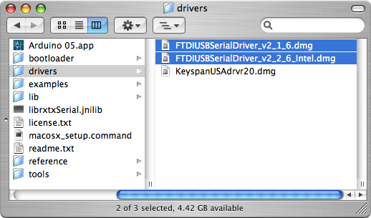

The latest version of the drivers can be found on the [FTDI website](http://www.ftdichip.com/Drivers/VCP.htm).

### 4 | Connect the board

If you're using a serial board, power the board with an external power supply (6 to 25 volts DC, with the core of the connector positive). Connect the board to a serial port on your computer.

On the USB boards, the power source is selected by the jumper between the USB and power plugs. To power the board from the USB port (good for controlling low power devices like LEDs), place the jumper on the two pins closest to the USB plug. To power the board from an external power supply (needed for motors and other high current devices), place the jumper on the two pins closest to the power plug. Either way, connect the board to a USB port on your computer. On Windows, the Add New Hardware wizard will open; tell it you want to specify the location to search for drivers and point to the folder containing the USB drivers you unzipped in the previous step.

The power LED should go on.

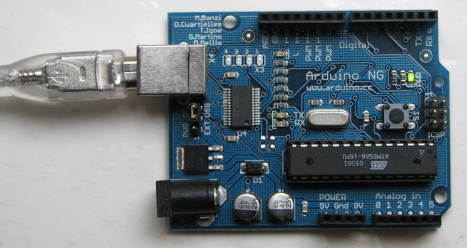

### 5 | Upload a program

Open the LED blink example sketch: File > Sketchbook > Examples >led blink.

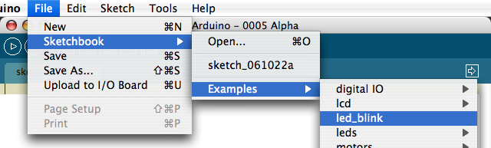

Here's what the code for the LED blink example looks like.

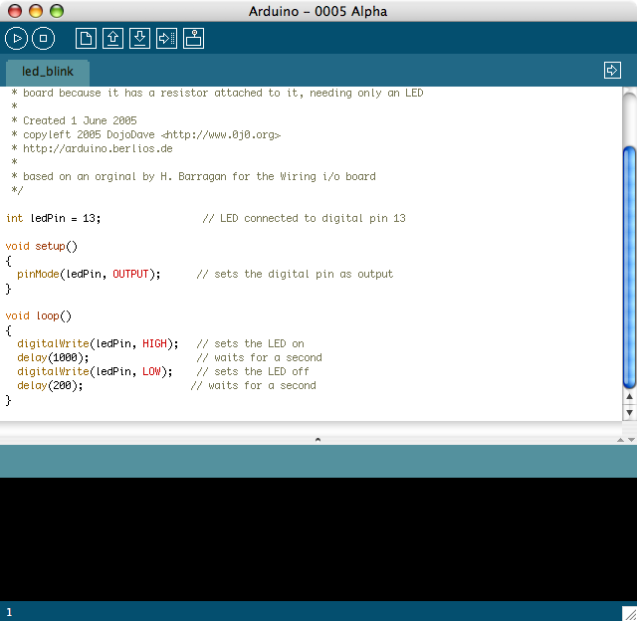

Select the serial device of the Arduino board from the Tools | Serial Port menu. On Windows, this should be COM1 or COM2 for a serial Arduino board, or COM3, COM4, or COM5 for a USB board. On the Mac, this should be something like /dev/cu.usbserial-1B1 for a USB board, or something like /dev/cu.USA19QW1b1P1.1 if using a Key span adapter with a serial board (other USB-to-serial adapters use different names).

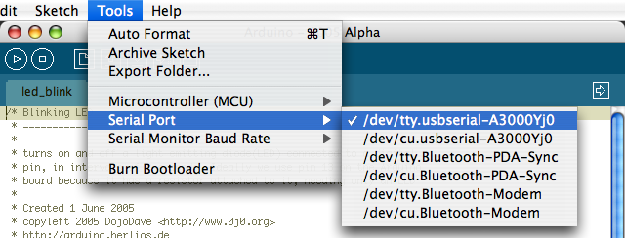

Push the reset button on the board then click the Upload button in the IDE. Wait a few seconds. If successful, the message "Done uploading." will appear in the status bar.

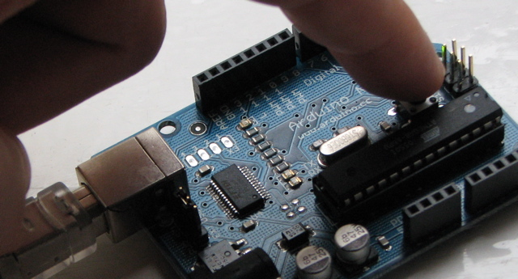



If the Arduino board doesn't show up in the Tools | Serial Port menu, or you get an error while uploading, please see the [FAQ](https://www.arduino.cc/en/Main/FAQ) for troubleshooting suggestions.A few seconds after the upload finishes, you should see the amber (yellow) LED on the board start to blink.

**CHAPTER -17**

**FLOW CHART**

GPS WILL START LOCATING THE LOCATION OF THE LOPIFIT

LCD DISPLAY & LED MODULE WILL TURN ON

ARDUINO WILL TURN ON

START

MOTOR DRIVER WILL STARTS & TURN ON THE MOTORS

LED WILL BLINK WHEN THE THREAD MILL STARTS WORKING

LCD DISPLAY WILL PRINT MSD TEAM 8

GSM MODULE WILL SATRT COMMUNICATING WITH THE REGISTERED MOBILE

BATTERY WILL CHARGE FROM THE ROTATION OF THE MOTOR

**17.2 PROGRAM**

#include<Liquidcrystal.h>

void setup() {

pinMode(2, OUTPUT);

pinMode(3, OUTPUT);

pinMode(4, OUTPUT);

}

void loop() {

digitalWrite(2, LOW);

delay(500);

digitalWrite(2, HIGH);

delay(500);

digitalWrite(3, LOW);

delay(500);

digitalWrite(3, HIGH);

delay(500);

digitalWrite(4, LOW);

delay(500);

digitalWrite(4, HIGH);

delay(500);

}

Liquidcrystal lcd(12,11,5,4,3)

Voidsetup()

{

Lcd.begin(16,2);

Lcd.print(“MSD TEAM 8”);

}

Void loop(){

}

//Motor1

const int MotorPin1 = 5;

const int MotorPin2 = 6;

//Motor2

const int MotorPin3 = 10;

const int MotorPin4 = 9;

void setup() {

  // put your setup code here, to run once:

  pinMode(MotorPin1, OUTPUT);

  pinMode(MotorPin2, OUTPUT);

  pinMode(MotorPin3, OUTPUT);

  pinMode(MotorPin4, OUTPUT);

}

void loop() {

  // put your main the code here, to run repeatedly:

  //Turn on Motor1 in clockwise for 3 second

  digitalWrite(MotorPin1, HIGH);

  digitalWrite(MotorPin2, LOW);

  digitalWrite(MotorPin3, LOW);

  digitalWrite(MotorPin4, LOW);

delay(2000);

  //Turn on Motor1 in anti-clockwise for 3 second

  digitalWrite(MotorPin1, LOW);

  digitalWrite(MotorPin2, HIGH);

  digitalWrite(MotorPin3, LOW);

  digitalWrite(MotorPin4, LOW);

delay(2000);

  //Turn on Motor2 in clockwise for 3 second

  digitalWrite(MotorPin1, LOW);

  digitalWrite(MotorPin2, LOW);

  digitalWrite(MotorPin3, HIGH);

  digitalWrite(MotorPin4, LOW);

delay(2000);

  //Turn on motor2 in Anti-clockwise for 3 second

  digitalWrite(MotorPin1, LOW);

  digitalWrite(MotorPin2, LOW);

  digitalWrite(MotorPin3, LOW);

  digitalWrite(MotorPin4, HIGH);

delay(2000);

//Turn on motor1 and motor2 in clockwise for 3 second

  digitalWrite(MotorPin1, HIGH);

  digitalWrite(MotorPin2, LOW);

  digitalWrite(MotorPin3, HIGH);

  digitalWrite(MotorPin4, LOW);

delay(2000);

//Turn on motor1 and motor2 in anti-clockwise for 3 second

  digitalWrite(MotorPin1, LOW);

  digitalWrite(MotorPin2, HIGH);

  digitalWrite(MotorPin3, LOW);

  digitalWrite(MotorPin4, HIGH);

delay(2000);

//Turn off motor1 and motor2 for 5 second

  digitalWrite(MotorPin1, LOW);

  digitalWrite(MotorPin2, LOW);

  digitalWrite(MotorPin3, LOW);

  digitalWrite(MotorPin4, LOW);s

}

**CHAPTER-18**

**18.1 ADVANTAGES**

* Battery Operated
* Easy to design
* User friendly
* Low cost
* Compact in size

**18.2 DISADVANTAGES**

**18.3 LIMITATIONS**

* Suitable for short distances only
* Not suitable for off road travelling
* Maintenance is needed.

**18.4 APPLICATIONS**

* Can be used as domestic purpose vehicles.
* Can be used in Corporate Offices for the internal transportation.
* Can be used in Educational intuitions.

**PROJECT PHOTOGRAPH**

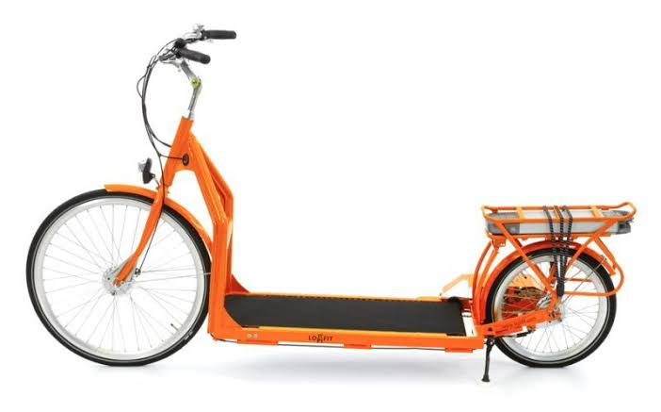

**CONCLUSION**

To make sure that our project “LOPIFIT” is based on the technical idea of the combination of all the process in one machine using microcontroller.

We have gathered more knowledge on our core subject Mechatronics, the combination of mechanical, electrical, computer, microcontroller programming and through the medium of this project. While doing this project, we had faced many problems but we have trouble-shooted one by one.

**BIBLIOGRAPHY**

**WEBSITES**

* [**www.electronicshub.com**](http://www.electronicshub.com)
* [**www.wikipedia.com**](http://www.wikipedia.com)
* [**www.electronicscircuits.com**](http://www.electronicscircuits.com)
* [**www.lopifit.us**](http://www.lopifit.us)
* [**www.circuitdigest.com**](http://www.circuitdigest.com)